Experiment – Prompt Engineering Techniques
Task Description
Design and refine prompts using different prompting strategies to generate Python programs for basic computational problems.

Question 1: Zero-Shot Prompting (Palindrome Number Program)
Write a zero-shot prompt (without providing any examples) to generate a Python function that checks whether a given number is a palindrome
Task:
- Record the AI-generated code.
- Test the code with multiple inputs.
- Identify any logical errors or missing edge-case handling.

PROMPT:
Write a python function that takes an integer as input and checks whether the number is palindrome.Return True if the number is a palindrome and false otherwise .Handle appropriate edge cases.
CODE:
def is_palindrome(num):
# Handle edge case for negative numbers
if num < 0:
return False

# Convert the number to string to check for palindrome
str_num = str(num)

# Check if the string is equal to its reverse
return str_num == str_num[::-1]
# Example usage:
print(is_palindrome(121)) # Output: True
print(is_palindrome(-121)) # Output: False
print(is_palindrome(10)) # Output: False
print(is_palindrome(12321)) # Output: True

OUTPUT:
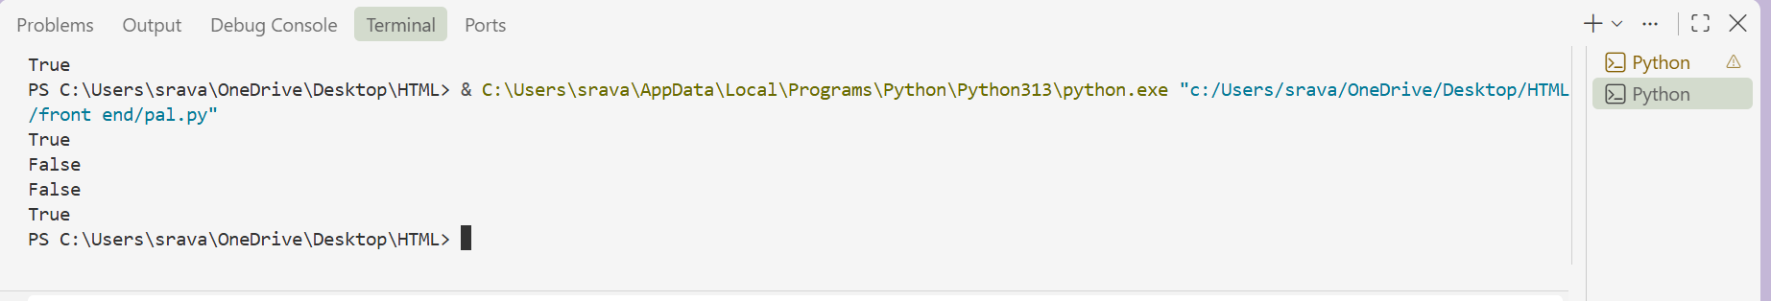

Question 2: One-Shot Prompting (Factorial Calculation)
Write a one-shot prompt by providing one input-output example and ask the AI to generate a Python function to compute the factorial of a given number.
Example:
Input: 5 → Output: 120
Task:
- Compare the generated code with a zero-shot solution.
- Examine improvements in clarity and correctness.
PROMPT:
Write a Python function that takes a number as input and calculates its factorial. The function should return the factorial of the given number.
CODE:
def factorial(number):
"""Return the factorial of a non-negative integer."""
if not isinstance(number, int) or number < 0:
raise ValueError("number must be a non-negative integer")

result = 1
for value in range(2, number + 1):
result *= value
return result
OUTPUT:
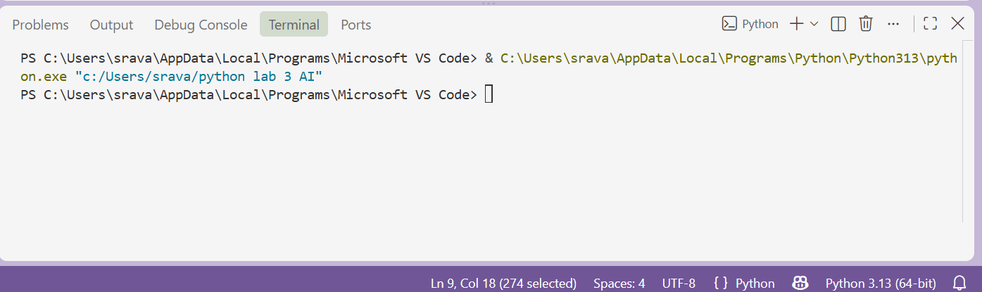

Question 3: Few-Shot Prompting (Armstrong Number Check)
Write a few-shot prompt by providing multiple input-output examples to guide the AI in generating a Python function to check whether a given number is an Armstrong number.
Examples:
- Input: 153 → Output: Armstrong Number
- Input: 370 → Output: Armstrong Number
- Input: 123 → Output: Not an Armstrong Number
Task:
- Analyze how multiple examples influence code structure and accuracy.
- Test the function with boundary values and invalid inputs.
PROMPT:
GENERTE A Python function named is_armstrong() to check whether a given number is an Armstrong number.
Use the following examples as guidance:
Example 1:
Input: 153
Output: Armstrong Number
Example 2:
Input: 370
Output: Armstrong Number
Example 3:
Input: 123
Output: Not an Armstrong Number
Based on these examples, write a Python function that:
- Accepts a number as input.
- Counts the number of digits.
- Raises each digit to the power of the number of digits.
- Adds the resulting values.
- Compares the sum with the original number.
- Returns "Armstrong Number" if they are equal.
- Returns "Not an Armstrong Number" otherwise.
- Handles boundary values such as 0 and 1.
- Handles negative numbers appropriately.
- Handles invalid inputs such as strings, floating-point numbers, and None without crashing.
Finally, test the function using the following inputs:
0, 1, 153, 370, 123, 9474, -153, "153", 153.0, None
Display the input and corresponding output for each test case.
CODE:
def is_armstrong(number):
"""Return whether *number* is an Armstrong number."""
if isinstance(number, bool) or not isinstance(number, int) or number < 0:
return "Not an Armstrong Number"

digits = str(number)
power = len(digits)
total = sum(int(digit) ** power for digit in digits)

return "Armstrong Number" if total == number else "Not an Armstrong Number"

test_inputs = [0, 1, 153, 370, 123, 9474, -153, "153", 153.0, None]

for value in test_inputs:
print(f"Input: {value!r} -> Output: {is_armstrong(value)}")
OUTPUT:
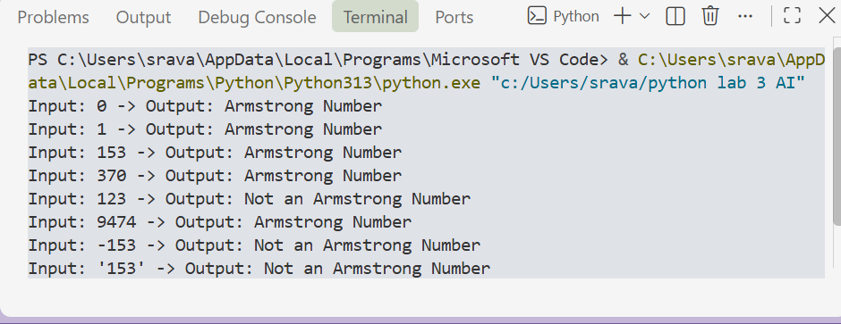

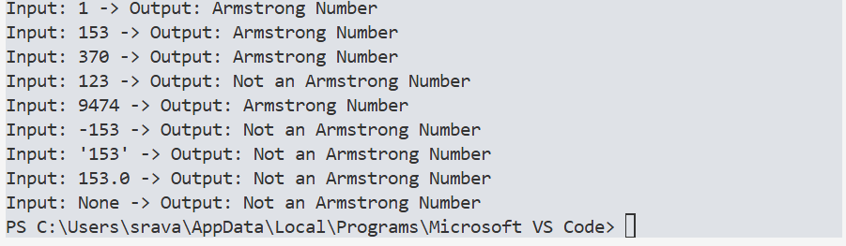

(Optional Extension)
Question 4: Context-Managed Prompting (Optimized Number Classification)
Design a context-managed prompt with clear instructions and constraints to generate an optimized Python program that classifies a number as prime, composite, or neither.
Task:
- Ensure proper input validation.
- Optimize the logic for efficiency.
- Compare the output with earlier prompting strategies.
PROMPT:
Generate an optimized Python function classify_number() that classifies an input as Prime, Composite, or Neither.
Requirements:
- Validate inputs and return "Invalid Input" for strings, floats, None, or Boolean values.
- Return "Neither" for numbers ≤ 1.
- Return "Prime" or "Composite" correctly.
- Optimize the logic by checking divisors only up to √n.
- Test with: 2, 4, 17, 100, 0, 1, -5, "17", 10.5, None.
- Briefly explain the optimization and compare this approach with zero-shot and few-shot prompting.
CODE:
from math import isqrt

def classify_number(number):
"""Classify an integer as Prime, Composite, or Neither."""
if isinstance(number, bool) or not isinstance(number, int):
return "Invalid Input"
if number <= 1:
return "Neither"
if number == 2:
return "Prime"
if number % 2 == 0:
return "Composite"

for divisor in range(3, isqrt(number) + 1, 2):
if number % divisor == 0:
return "Composite"
return "Prime"

test_inputs = [2, 4, 17, 100, 0, 1, -5, "17", 10.5, None]

for value in test_inputs:
print(f"Input: {value!r} -> Output: {classify_number(value)}")

OUTPUT:
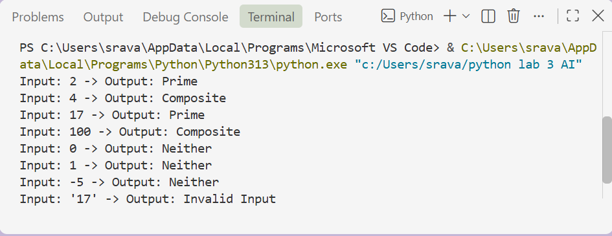
Question 5: Zero-Shot Prompting (Perfect Number Check)
Write a zero-shot prompt (without providing any examples) to generate a Python function that checks whether a given number is a perfect number.
Task:
- Record the AI-generated code.
- Test the program with multiple inputs.
- Identify any missing conditions or inefficiencies in the logic.

PROMPT:
Generate a Python function named is_perfect_number() that checks whether a given number is a perfect number.

A perfect number is a positive integer that is equal to the sum of its proper positive divisors.

The function should return "Perfect Number" if the number is perfect and "Not a Perfect Number" otherwise.

Handle invalid inputs appropriately and use an efficient approach to find the divisors.

Test the function with multiple inputs, including boundary values and invalid inputs, and display the results.
CODE:
from math import isqrt

def is_perfect_number(number):
"""Return whether number is a positive perfect integer."""
if isinstance(number, bool) or not isinstance(number, int) or number <= 0:
return "Not a Perfect Number"
if number == 1:
return "Not a Perfect Number"

divisor_sum = 1
for divisor in range(2, isqrt(number) + 1):
if number % divisor == 0:
divisor_sum += divisor
paired_divisor = number // divisor
if paired_divisor != divisor:
divisor_sum += paired_divisor

return "Perfect Number" if divisor_sum == number else "Not a Perfect Number"

test_inputs = [1, 2, 6, 28, 496, 8128, 10, 0, -6, "6", 6.0, None]

for value in test_inputs:
print(f"Input: {value!r} -> Output: {is_perfect_number(value)}")
OUTPUT:
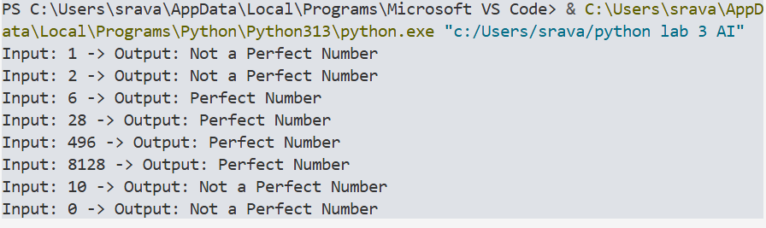
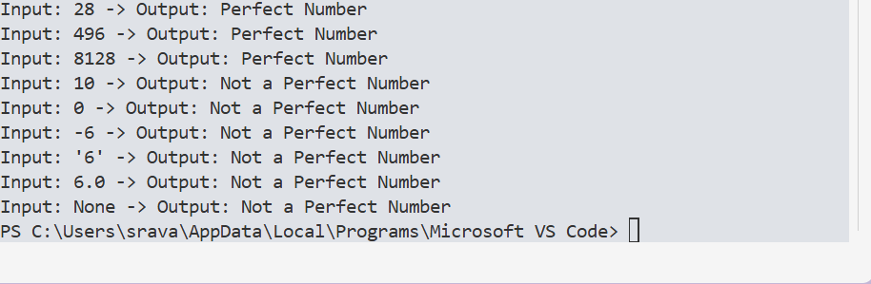

Question 6: Few-Shot Prompting (Even or Odd Classification with Validation)
Write a few-shot prompt by providing multiple input-output examples to guide the AI in generating a Python program that determines whether a given number is even or odd, including proper input validation.
Examples:
- Input: 8 → Output: Even
- Input: 15 → Output: Odd
- Input: 0 → Output: Even
Task:
- Analyze how examples improve input handling and output clarity.
- Test the program with negative numbers and non-integer inputs.
PROMPT:
Write a Python function check_even_odd() to classify a number as Even or Odd.
Examples:
8 → Even
15 → Odd
0 → Even
Requirements:
- Return "Invalid Input" for strings, floats, None, and Boolean values.
- Handle negative numbers correctly.
- Test with 8, 15, 0, -4, -7, "8", 10.5, None, True.
- Print each input and output.
CODE:
def check_even_odd(number):
"""Return whether an integer is even or odd, or reject invalid input."""
if isinstance(number, bool) or not isinstance(number, int):
return "Invalid Input"
return "Even" if number % 2 == 0 else "Odd"

test_values = [8, 15, 0, -4, -7, "8", 10.5, None, True]

for value in test_values:
print(f"{value} -> {check_even_odd(value)}")
OUTPUT:
